**Face Mask Detection Model for the identification of non-masked faces using an Artificial Neural Network**

Amit Kumar Rai1, Rupam Dasgupta2, Sandip Ghosh3, Rounak Banerjee4, Renesa Chakraborty5, Saptarshi Banerjee6, Shouvik Neogi7

1Assistant Professor, Department of Electronics & Communication Engineering, Asansol Engineering College, Asansol, W.B

2, 3, 4, 5, 6,7Undergraduate Scholar, Department of Electronics & Communication Engineering, Asansol Engineering College, Asansol, W.B

[1amitrai2212@gmail.com](mailto:1amitrai2212@gmail.com), 2[www.rupamdasgupta@gmail.com](http://www.rupamdasgupta@gmail.com), 3[sgsandipghosh.472@gmail.com](mailto:sgsandipghosh.472@gmail.com), 4[rounakbanerjee327@gmail.com](mailto:rounakbanerjee327@gmail.com), 5[renesachakraborty47163@gmail.com](mailto:renesachakraborty47163@gmail.com), 6[saptarshibanerjee2310@gmail.com](mailto:saptarshibanerjee2310@gmail.com), [7shouvikneogi692000@gmail.com](mailto:7shouvikneogi692000@gmail.com)

**ABSTRACT**: The corona virus, COVID-19 pandemic is causing a global health crisis. The outbreak of COVID-19 has taught everyone the importance of face masks in their lives. SARS-COV-2 (severe acute respiratory syndrome) is a communicable virus that is transmitted from person to person while speaking, sneezing in the form of respiratory droplets. It spreads on coming in close proximity with an infected person. Governments of different countries did impose a fully-fledged lockdown to minimize the risk of transmission. As stated by World Health Organization (WHO), the effective protection method to prevent the spread of Covid is wearing a proper face mask.

With the advancement of newer technologies, deep learning and computer vision have proved to be an effective way in facial recognition through image processing. In our project, we propose to build a COVID-19 face mask detector system with computer vision using Python, OpenCV, and Tensor Flow and Keras. In our presented system, we will use live video stream and finally the person who is not wearing face masks can be recognized using advanced image processing technique with the help of Computer Vision and Deep Learning. If case a person is not wearing the face mask, then a SMS alert is sent to the concerned person’s mobile. The proposed model provided excellent test accuracy of 99%.

1. **INTRODUCTION**

Wearing masks in public is not just a trend now but an absolute necessity. Due to this COVID-19 pandemic, governments from different countries have forged absolute laws. In India, with the help of various hoardings, advertisements, even in the mobile caller tunes, the absolute necessity of wearing a face mask is shown.

Though, various steps have been taken, their lies loopholes as well. There comes our technology into play.

Technologies like Machine Learning, Artificial Intelligence are the ones with which we can easily tackle our problems.

The very first step is Face Detection.

The main aim of face detection can be divided into:-

1. To find out whether there is any face in the given screen/image or stream or not and
2. If, yes whether the person is wearing a face mask or not.The face MASK detection model is based on computer vision and deep learning. The model is integrationbetween deep learning and classicalmachine learning techniques with OpenCV, Tensorflow and Keras.[1]

We have used the Open CV Haar Cascade Model to detect face within frames and the Residual Net Architecture is used to detect mask on a face. Our project can be implemented on traffic cameras to get frames and predict whether a person wears a mask or not.

There are several other procedures that can build a Facial Mask Detection for instance, [2]used electromagnetic and radiometry techniques for facial masks detection. [3]Employed deep neural networks (ANN) using machine learning techniques in Facial Masks detection.[4] Neural Networks are used to exacted information from ultrasound to classify the abnormal lesions.[5] Presented a face feature detection method based on Ultrasound RF Time series and SVM Classifier. The characteristics curve of 0.86 using support vector machine (SVM) and 0.81using RF classification algorithm on 22 subjects was determined.

1. **METHODOLOGY**

Our project works by capturing live frames from various cameras connected to the system and detecting faces within those frames. After that we need to preprocess the image as per the model's requirements and feeding the images to the model and get the prediction whether a face consist of mask or not. If a face does not have a mask on it, the face is searched in a database to get the information of the person and finally a SMS notification is sent to the concerned person.

We keep count of all the notifications sent to the concerned person and when this count exceeds the maximum limit of warning that should be sent, then the person will be marked and appropriate legal action will be taken against the person by concerned authorities.

Note:- Action which will be taken against the person shall be decided by the governing body where the software is implemented.

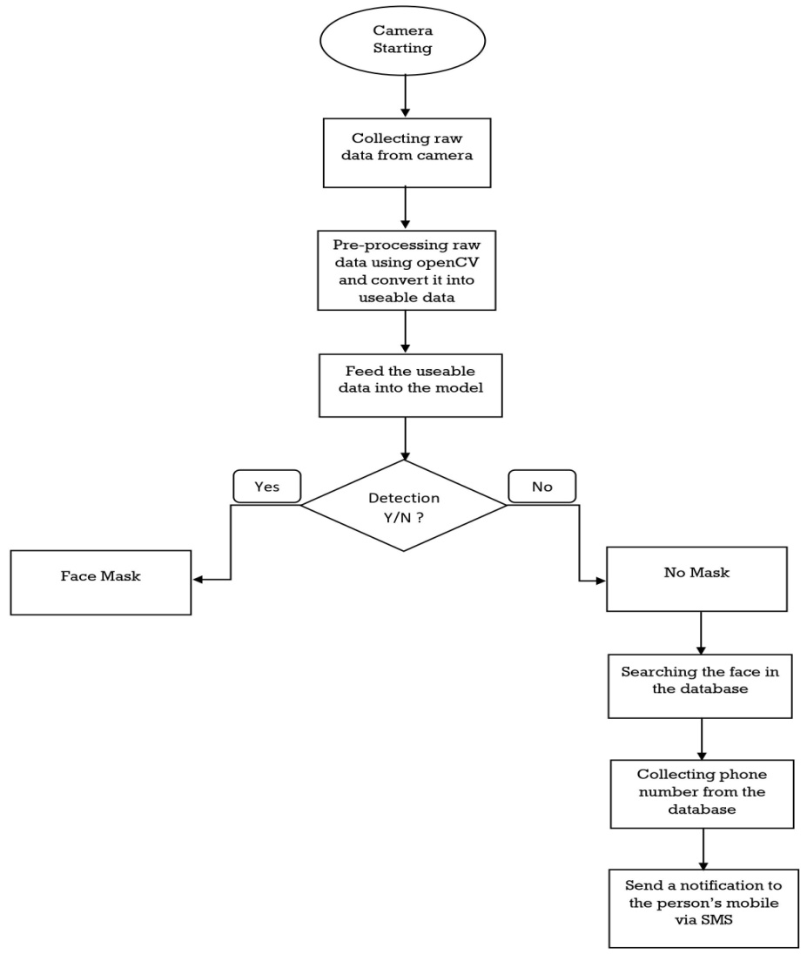

Figure 1 shows the total work line of our entire project

1. **DATA STORE**

We have used IBM DB2 as our database to store information of all users for their idenditification. The Schema of our database consist of two tables:-

1. USER_INFO (User Id (Primary Key), Name, Country Code, Phone no., Email, Address)).

2. USER_IMAGE (Id (Primary Key), Mask Image, Unmask Image, User Id (Foreign Key)).

**OUTCOME**

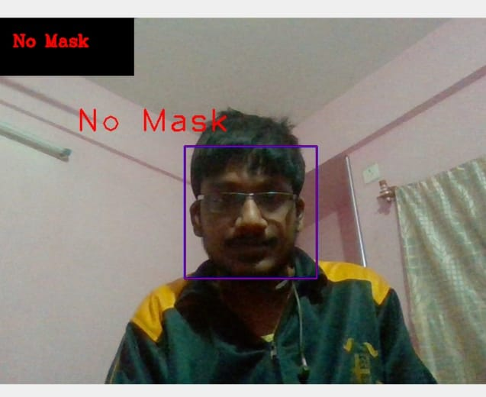

Fig(4) 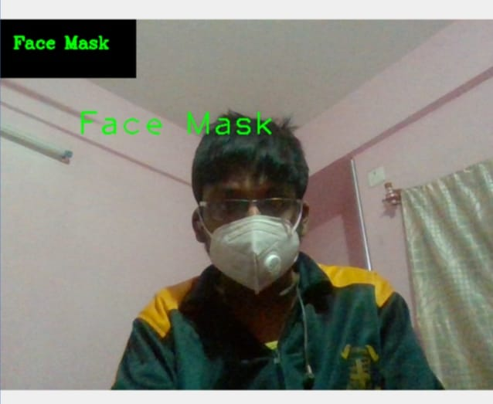

Fig(5)

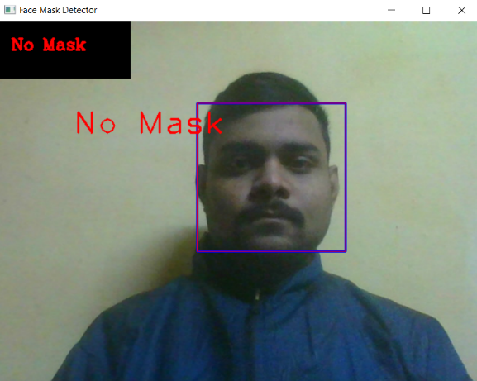Fig(5) 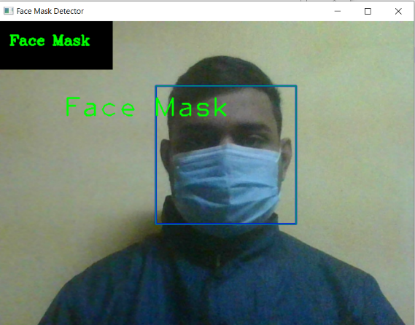

Fig(6)

(Figures 4 and 6 shows un-masked pictures and 5 and 6 shows masked images.)

**CONCLUSION**

On referring various articles and papers, we have come to understand the challenges faced in Face Detection.

Upon development of face mask, we can detect the person wearing a face mask or not.

The main purpose is reducing people’s transmission through this System.

**REFERENCES**

[1][https://www.who.int/docs/default-source/coronaviruse/situation-reports/20200816-covid-19-sitrep-209.pdf?sfvrsn=5dde1ca2_2](https://www.sciencedirect.com/science/article/pii/S2468042720300117?via=ihub)

[2]kepenekci, b., and akar, g. b. (2004, april). face classification with support vector machine. ieee 12th signal processing and communications applications conference, 2004. (pp. 583-586). ieee

[3] h. anandakumar and k. umamaheswari, a bio-inspired swarm intelligence technique for social aware cognitive radio handovers, computers & electrical engineering, vol. 71, pp. 925–937, oct. 2018. doi:10.1016/j.compeleceng.2017.09.016

[4] r. arulmurugan and h. anandakumar, early detection of lung cancer using wavelet feature descriptor and feed forward back propagation neural networks classifier, lecture notes in computational vision and biomechanics, pp. 103–110, 2018. doi:10.1007/978-3-319-71767-8_9.

[5] vu, n. s., and caplier, a. (2010, september). face recognition with patterns of oriented edge magnitudes. (pp. 313-326). springer, berlin,heidelberg.